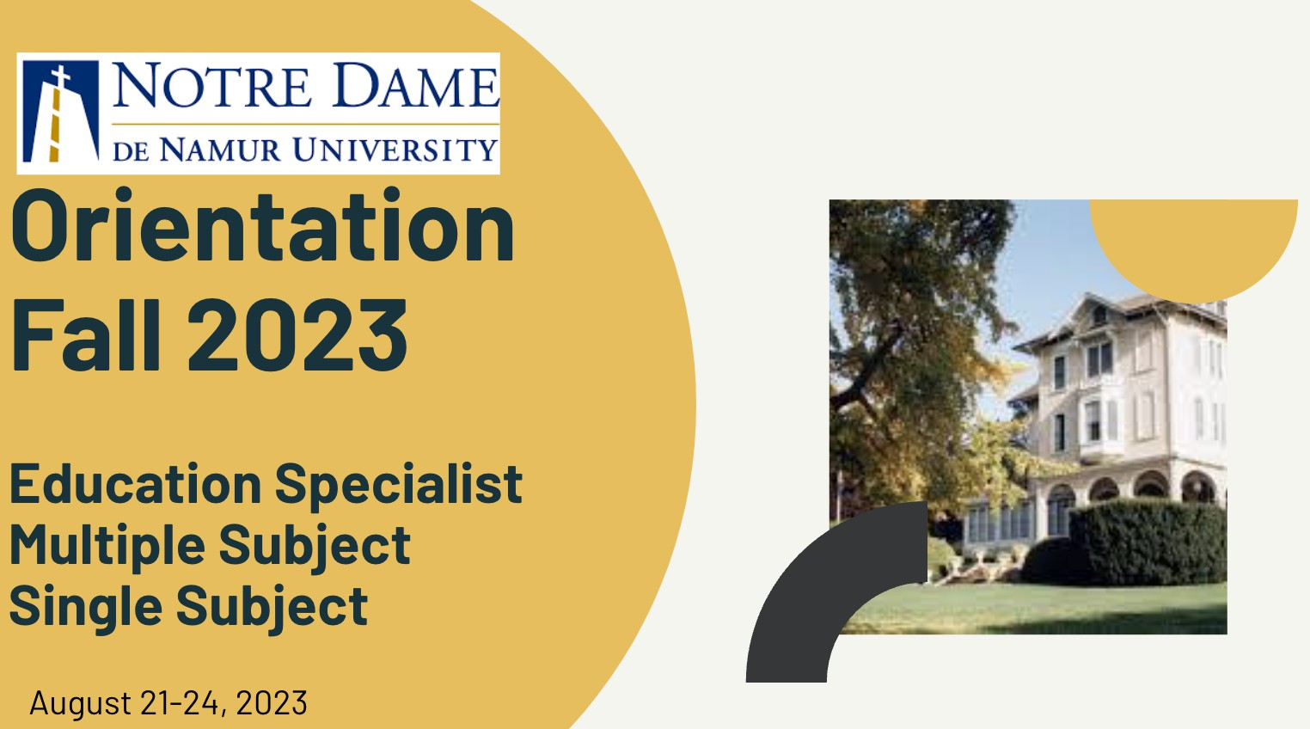  Orientation Slides | Notre Dame de Namur University | 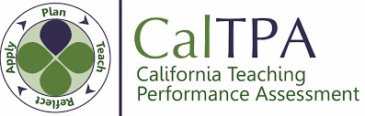  Cal TPA
Relive the highlights of orientation!  Schedule of Presenters | 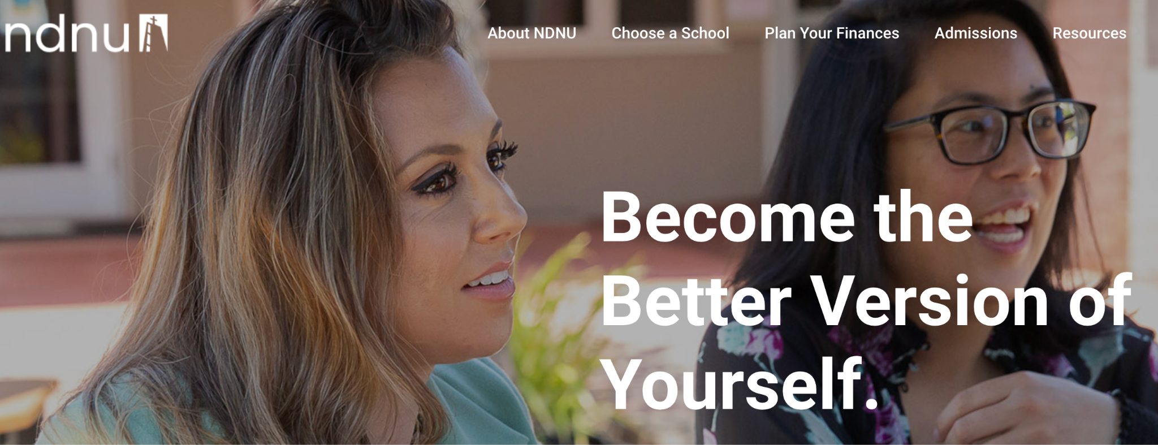  Academic Success Center Life & Wellness Resources  Calendar Academic Year 22-23 | Registration Link  How to register for Cal TPA: Presentation Slide Deck  Presenter:  Kelly Vaughn  kvaughn@ndnu.edu
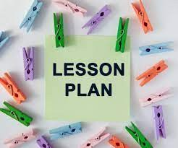  Lesson Planning | NDNU Fall Orientation  August 21-24, 2023 | 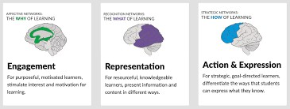  Universal Design for Learning (UDL)
NDNU Annotated Sample Template | 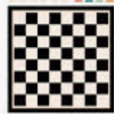  Resources Game Boar  Move around the game board to review the week’s activities and learning. | Resources:  Video: The Myth of Average Video: The 7-10 Split  UDL Overview & Resources UDL at a Glance
 | Bookmark this page for reference.*
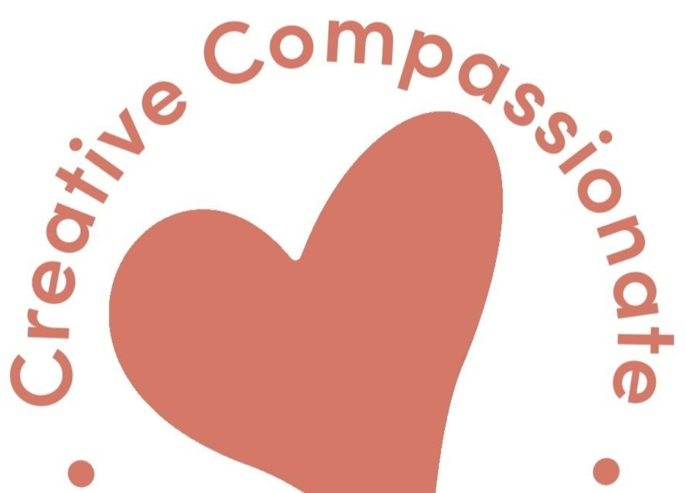  Arts Integration |   Physical Education |   Music Instruction
Creative Compassio11afe Webdife  Folder of Resources | Presenter:  Cameron Oates  cameron.oates@sesd.org | Presenter:  Roger Jones  rojoprodo@gmail.com
Presenter:

